IOTA Synchronization

Aki Yoshida JA1NLX

1.0 GENERAL

Logger32 provides a feature which synchronizes IOTA Credit Granted flags with the status on RSGB/IOTA database.

2.0 DOWNLOAD YOUR QSOs FOR EACH IOTA

If you are registered then go to https://www.rsgbiota.org/index.php https://www.iota-world.org/en/ and log in. Click My Credits IOTA Tab. Click the Link “Download all QSOs (CSV)” to download the file, myqsos.csv anywhere you like..

The myqsos.csv file consists of the following data:

  - IOTA reference number;
  - Callsign;
  - UTC;
  - Count for; and,
  - Status;

This is either of “QSL”, “Contest”, “Accepted Operation” or “Not submitted”

If your credit application is accepted by QSL card then it is “QSL”;
If your credit application is accepted by IOTA Contest Log then it is “Contest”;
If your credit is accepted by ClubLog then it is “Accepted Operation”.
If you only add QSO manually or by ClubLog QSO matches then it is “Not submitted”

  - No header;

Accepted: credited

Active: not credited yet

This is a part of myqsos.csv.

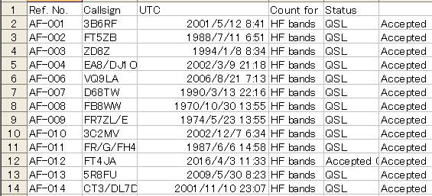

ISY_1

Note: If you have any of IOTA credited prior to August 2007 then YOUR myqsos.csv looks may be different. There may be many records with “00000000” as UTC. You see 2 extra columns, Freq and Mode, “Method” instead of “Status” header and “Status” instead of blank header. It looks like below.

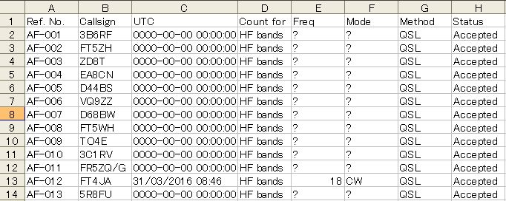

ISY_1A

You may notice following QSO at the end of the file. The most right column shows "Active". Thes are "Pending QSO" (not credited yet) Logger32 does not update flag for these QSO.

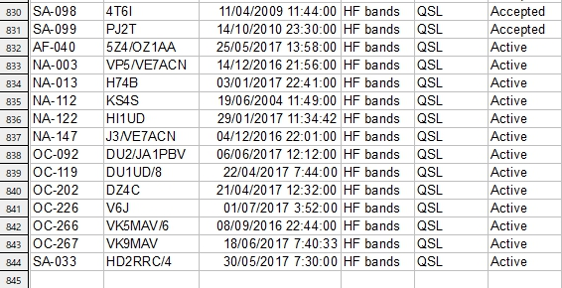

ISY_1B

3.0 SYNCHRONIZE IOTA

Click File and Synchronize IOTA (from a CSV file).

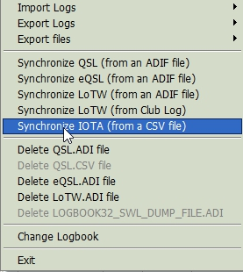

new ISY_2

You must select myqsos.csv which you downloaded in step 2.0.

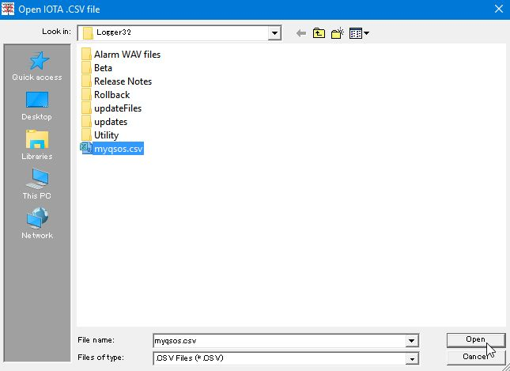

ISY_2A

Click “Open”.

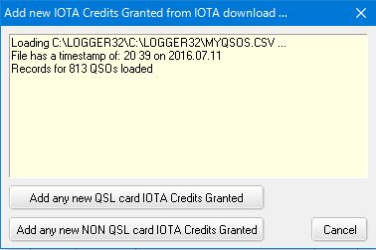

ISY_3

Logger32 read the file correctly only check if the file format is one like ISY_1 or ISY_1A and if UTC data is correctly formated. Otherwise it shows like this:

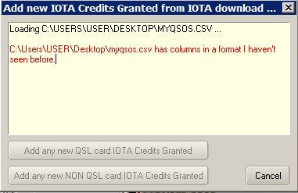

ISY_3A

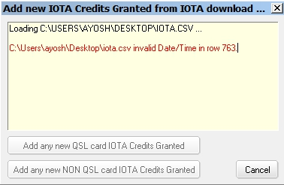

ISY_3B

In either case you must click "Cancel" and edit myqsos.csv.

Click “Add any new QSL card IOTA Credits Granted” Only QSO with “QSL” status will update Logbook.

Click “Add any new NON QSL card IOTA Credits Granted”. QSO with “Contest” or “Accepted Operation” status will update Logbook.

Note: QSO with “Not submitted Active” status do not update Logbook.

If Logger32 can not find matched QSO then you are now presented with a list of QSOs in your logbook that match the home call of the station you worked.

If a record in the myqsos.csv has date and time information and Logger32 can not find a matched QSO in the Logbook then following list is presented. Logger32 looks +/- 30 minutes either side of the reported QSO time and checks dates as dd/mm/yyyy and mm/dd/yyyy.

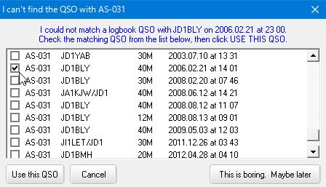

ISY_4

If a record in the myqsos.csv has no date and time information then following list is presented.

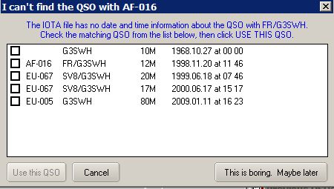

ISY_4A

In either case select a proper QSO and click “Use this QSO”.

These mapping are saved as <logbook name>_IOTA_QSO_MAP.txt in the Logger32 folder.

If the QSO is updated successfully you see a message like this for each QSO.

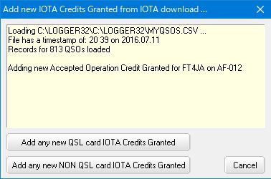

ISY_5

If Logger32 does not find any QSO to be updated then you see a message like this.

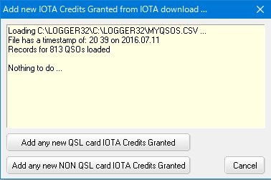

ISY-6

Note: You will be surprised to see lots of errors “Can’t find the QSO.....” It is unbelievable. I do not know who really made such a mistake.
Most of these are un-matched with Date/UTC and the rest are un-matched with callsign. (JA1NLX/3D2 or 3D2/JA1NLX). Logger32 does not change anything in Logbook except the Credit Granted flag even if it does not find any matched QSO. It only creates a mapping table.

